Mukesh Patel School of Technology & Management Engineering
Department of Artificial Intelligence & Data Science
Indore Campus

MINI PROJECT REPORT
Cab Booking Management System
Submitted by:
Pari Batra
Anvisha Patwa
Nehal Maheshwari

Programme: B.Tech AI & DS, Semester III

Submitted to: Dr. Divya Gautam

1. Problem Statement and Proposed Solution

1.1 Problem Statement
A cab service receives ride requests from customers throughout the day and must assign them to available cabs. Handling this manually or with unstructured data leads to unfair ordering of requests, slow lookups of cab details, no reliable record of assigned trips, and no way to reverse a wrongly assigned booking. The problem is to design a Cab Booking Management System that stores the cab fleet, lets a cab be searched by ID and ranked by fare, accepts ride requests and serves them strictly in the order received, computes the fare for each assigned ride, and keeps a trip history in which the latest booking can be undone.

1.2 Proposed Solution
The system is a menu-driven C program in which each responsibility is mapped to a data structure that suits its access pattern: an array of structures for the cab fleet, linear search for finding a cab by ID, bubble sort for ranking cabs by fare, a circular queue for pending ride requests (first come, first served), and a stack for trip history with an undo operation (last in, first out). No external library or database is used, so the focus stays on data structure selection, algorithm design, and complexity analysis.
Supported operations: (1) display cabs, (2) search a cab by ID, (3) sort cabs by fare, (4) add a ride request, (5) process the next ride request, (6) display trip history, (7) undo the last trip, and (0) exit.

2. Selection and Justification of Data Structures
Requirement | Data Structure / Technique | Justification
Store the cab fleet (ID, driver, fare per km, status) | Array of structures (Cab[]) | Fixed-format records with a known maximum size (10). Direct indexing gives O(1) access and simple traversal for display, sorting, and searching.
Find a cab by its ID | Linear Search on the array | The fleet is small and kept in fare order after sorting, not ID order, so it is not sorted by ID. Linear search needs no ordering and is the correct choice for unsorted data.
Rank cabs by fare (lowest first) | Bubble Sort | Simple in-place sort that suits a small array. Once sorted, the first available cab in the array is the cheapest available one.
Serve ride requests in arrival order | Circular Queue (array based) | Requests must be served first come, first served, which is exactly FIFO. Wrap-around with modulo arithmetic reuses freed slots, so no space is wasted after dequeues.
Keep trip history and undo the latest booking | Stack (array based) | The most recent trip is the one that gets reviewed first and undone, which is LIFO. Push and pop are O(1), and the top index always points at the latest trip.

Together these cover arrays (CO1), searching and sorting (CO2), and linear data structures — queue and stack (CO4) — in one connected application: a request enters the queue, is dequeued and assigned to a cab from the array, recorded on the stack, and can be undone by popping it.

3. Algorithm / Pseudocode / Flowchart

3.1 Main Menu Flowchart
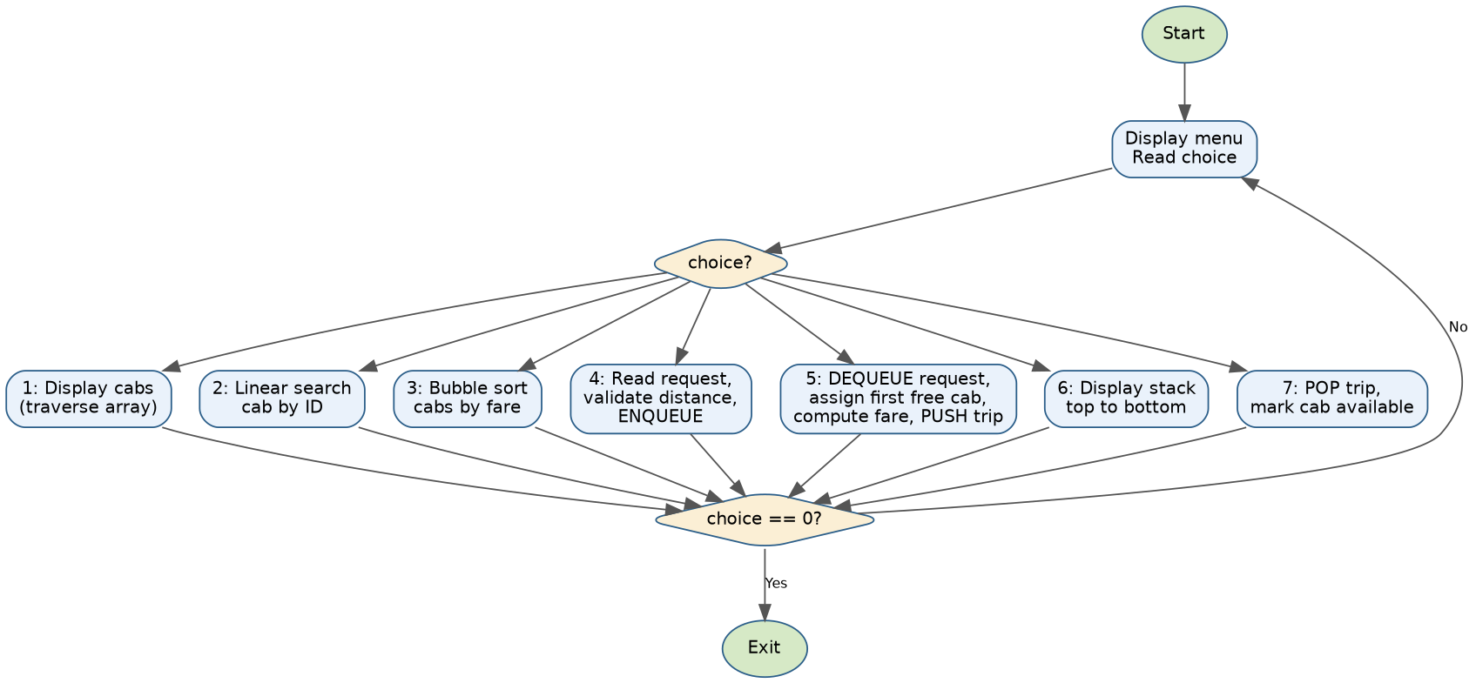

3.2 Flowchart: Process Next Ride Request
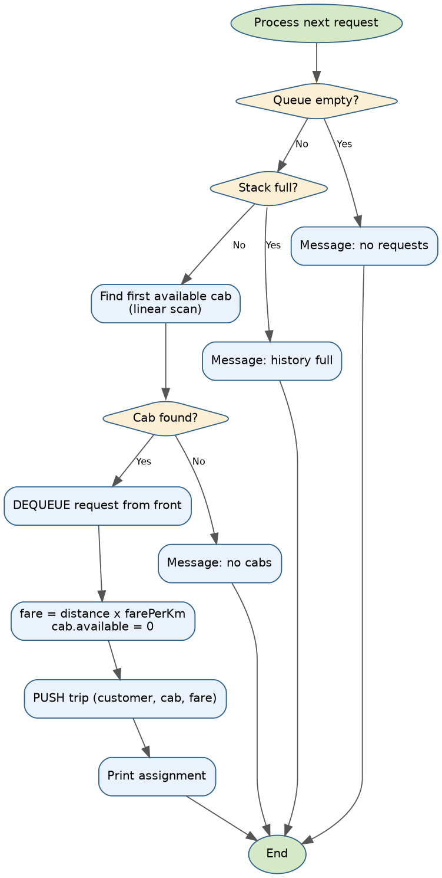

3.3 Pseudocode

(a) Linear search of a cab by ID
ALGORITHM SearchCab(id)
FOR i <- 0 TO cabCount-1 DO
IF cabs[i].id == id THEN
PRINT driver, fare, status ; RETURN
PRINT "Cab not found"

(b) Bubble sort of cabs by fare
ALGORITHM SortCabsByFare()
FOR i <- 0 TO cabCount-2 DO
FOR j <- 0 TO cabCount-i-2 DO
IF cabs[j].fare > cabs[j+1].fare THEN SWAP(cabs[j], cabs[j+1])

(c) Circular queue: add a ride request
ALGORITHM AddRideRequest()
IF (rear+1) mod MAX == front THEN PRINT "Queue full" ; RETURN
READ customerId, pickup, destination, distance
IF distance <= 0 THEN PRINT "Invalid distance" ; RETURN
IF front == -1 THEN front <- 0
rear <- (rear+1) mod MAX
requests[rear] <- request

(d) Process the next ride request (dequeue + push)
ALGORITHM ProcessRideRequest()
IF front == -1 THEN PRINT "No requests" ; RETURN
IF top == MAX-1 THEN PRINT "History full" ; RETURN
cabIndex <- first i with cabs[i].available == 1, else -1
IF cabIndex == -1 THEN PRINT "No cabs available" ; RETURN
request <- requests[front]
IF front == rear THEN front <- rear <- -1
ELSE front <- (front+1) mod MAX
fare <- request.distance * cabs[cabIndex].farePerKm
cabs[cabIndex].available <- 0
top <- top+1 ; trips[top] <- (customerId, cabId, fare)
PRINT assignment details

(e) Undo the last trip (pop)
ALGORITHM UndoLastTrip()
IF top == -1 THEN PRINT "No trip to undo" ; RETURN
lastTrip <- trips[top] ; top <- top-1
FIND cab with id == lastTrip.cabId AND set available <- 1
PRINT confirmation

4. Implementation Code
#include <stdio.h>

#define MAX_CABS 10
#define MAX_REQUESTS 10
#define MAX_TRIPS 10

struct Cab
{
int id;
char driver[30];
float farePerKm;
int available;
};

struct RideRequest
{
int customerId;
char pickup[30];
char destination[30];
float distance;
};

struct Trip
{
int customerId;
int cabId;
float fare;
};

struct Cab cabs[MAX_CABS] =
{
{101, "Aman", 12.0, 1},
{102, "Riya", 10.0, 1},
{103, "Karan", 15.0, 1},
{104, "Neha", 11.0, 1}
};

int cabCount = 4;

struct RideRequest requests[MAX_REQUESTS];
int front = -1;
int rear = -1;

struct Trip trips[MAX_TRIPS];
int top = -1;

void displayCabs()
{
int i;

printf("\nCab List\n");
printf("ID\tDriver\tFare/km\tStatus\n");

for (i = 0; i < cabCount; i++)
{
printf("%d\t%s\t%.2f\t",
cabs[i].id,
cabs[i].driver,
cabs[i].farePerKm);

if (cabs[i].available == 1)
{
printf("Available\n");
}
else
{
printf("On trip\n");
}
}
}

void searchCab()
{
int id;
int i;
int found = 0;

printf("Enter cab ID to search: ");
scanf("%d", &id);

for (i = 0; i < cabCount; i++)
{
if (cabs[i].id == id)
{
printf("Cab found\n");
printf("Driver: %s\n", cabs[i].driver);
printf("Fare per km: %.2f\n", cabs[i].farePerKm);

if (cabs[i].available == 1)
{
printf("Status: Available\n");
}
else
{
printf("Status: On trip\n");
}

found = 1;
break;
}
}

if (found == 0)
{
printf("Cab not found.\n");
}
}

void sortCabsByFare()
{
int i;
int j;
struct Cab temp;

for (i = 0; i < cabCount - 1; i++)
{
for (j = 0; j < cabCount - i - 1; j++)
{
if (cabs[j].farePerKm > cabs[j + 1].farePerKm)
{
temp = cabs[j];
cabs[j] = cabs[j + 1];
cabs[j + 1] = temp;
}
}
}

printf("Cabs sorted by fare, lowest first.\n");
displayCabs();
}

int isQueueFull()
{
if ((rear + 1) % MAX_REQUESTS == front)
{
return 1;
}
else
{
return 0;
}
}

int isQueueEmpty()
{
if (front == -1)
{
return 1;
}
else
{
return 0;
}
}

void addRideRequest()
{
struct RideRequest request;

if (isQueueFull())
{
printf("The ride request queue is full.\n");
return;
}

printf("Enter customer ID: ");
scanf("%d", &request.customerId);

printf("Enter pickup location: ");
scanf("%s", request.pickup);

printf("Enter destination: ");
scanf("%s", request.destination);

printf("Enter distance in kilometres: ");
scanf("%f", &request.distance);

if (request.distance <= 0)
{
printf("Distance must be greater than zero.\n");
return;
}

if (isQueueEmpty())
{
front = 0;
}

rear = (rear + 1) % MAX_REQUESTS;
requests[rear] = request;

printf("Ride request added to the queue.\n");
}

void processRideRequest()
{
int cabIndex = -1;
int i;
float fare;

struct RideRequest request;

if (isQueueEmpty())
{
printf("There are no ride requests to process.\n");
return;
}

if (top == MAX_TRIPS - 1)
{
printf("Trip history is full.\n");
return;
}

for (i = 0; i < cabCount; i++)
{
if (cabs[i].available == 1)
{
cabIndex = i;
break;
}
}

if (cabIndex == -1)
{
printf("No cabs are currently available.\n");
return;
}

request = requests[front];

if (front == rear)
{
front = -1;
rear = -1;
}
else
{
front = (front + 1) % MAX_REQUESTS;
}

fare = request.distance * cabs[cabIndex].farePerKm;

cabs[cabIndex].available = 0;

top++;

trips[top].customerId = request.customerId;
trips[top].cabId = cabs[cabIndex].id;
trips[top].fare = fare;

printf("\nRide assigned successfully.\n");
printf("Customer ID: %d\n", request.customerId);
printf("Route: %s to %s\n", request.pickup, request.destination);
printf("Cab ID: %d\n", cabs[cabIndex].id);
printf("Driver: %s\n", cabs[cabIndex].driver);
printf("Fare: %.2f\n", fare);
}

void displayTripHistory()
{
int i;

if (top == -1)
{
printf("There are no completed trips.\n");
return;
}

printf("\nTrip History\n");

for (i = top; i >= 0; i--)
{
printf("Customer: %d | Cab: %d | Fare: %.2f\n",
trips[i].customerId,
trips[i].cabId,
trips[i].fare);
}
}

void undoLastTrip()
{
int i;
struct Trip lastTrip;

if (top == -1)
{
printf("There is no trip to undo.\n");
return;
}

lastTrip = trips[top];

top--;

for (i = 0; i < cabCount; i++)
{
if (cabs[i].id == lastTrip.cabId)
{
cabs[i].available = 1;
break;
}
}

printf("Last trip for customer %d was removed.\n",
lastTrip.customerId);

printf("Cab %d is available again.\n",
lastTrip.cabId);
}

int main()
{
int choice;

do
{
printf("\nCab Booking Management System\n");
printf("1. Display cabs\n");
printf("2. Search for a cab\n");
printf("3. Sort cabs by fare\n");
printf("4. Add a ride request\n");
printf("5. Process the next ride request\n");
printf("6. Display trip history\n");
printf("7. Undo the last trip\n");
printf("0. Exit\n");

printf("Enter your choice: ");
scanf("%d", &choice);

switch (choice)
{
case 1:
displayCabs();
break;

case 2:
searchCab();
break;

case 3:
sortCabsByFare();
break;

case 4:
addRideRequest();
break;

case 5:
processRideRequest();
break;

case 6:
displayTripHistory();
break;

case 7:
undoLastTrip();
break;

case 0:
printf("Exiting the program.\n");
break;

default:
printf("Invalid choice.\n");
}

} while (choice != 0);

return 0;
}

4.1 Sample Input and Output
The following test cases were run on the program. Each row shows the menu choice(s) entered and the resulting output.
Test | Input | Output
Search existing cab | 2, then ID 103 | Cab found; Driver: Karan; Fare per km: 15.00; Status: Available
Sort by fare | 3 | Order becomes 102 Riya (10.00), 104 Neha (11.00), 101 Aman (12.00), 103 Karan (15.00)
Add request | 4, then 501, MGRoad, Airport, 10 | Ride request added to the queue.
Add second request | 4, then 502, Station, Mall, 5 | Ride request added to the queue.
Process request 1 (FIFO) | 5 | Customer 501, MGRoad to Airport, Cab ID 102, Driver Riya, Fare: 100.00
Process request 2 | 5 | Customer 502, Station to Mall, Cab ID 104, Driver Neha, Fare: 55.00
Trip history | 6 | 502 / Cab 104 / 55.00 listed first, then 501 / Cab 102 / 100.00 (latest first)
Undo last trip | 7 | Last trip for customer 502 was removed. Cab 104 is available again.
Process with empty queue | 5 | There are no ride requests to process.

Because the cabs were sorted by fare before processing, the first available cab in the array was also the cheapest one (Riya at 10.00 per km, then Neha at 11.00 per km).

5. Time and Space Complexity Analysis
Let n be the number of cabs (cabCount) and t the number of trips in history.
Operation | Data Structure | Time | Space
Display cabs | Array | O(n) | O(1)
Search cab by ID | Array, linear search | O(n) worst, O(1) best | O(1)
Sort cabs by fare | Array, bubble sort (no early exit) | O(n²) in all cases | O(1) in place
Add ride request (enqueue) | Circular queue | O(1) | O(1)
Process ride request | Queue dequeue + cab scan + stack push | O(n), dominated by the scan for a free cab | O(1)
Display trip history | Stack | O(t) | O(1)
Undo last trip | Stack pop + cab lookup | O(n), dominated by the cab lookup | O(1)
Overall storage | Three fixed arrays | — | O(MAX_CABS + MAX_REQUESTS + MAX_TRIPS)

The queue and stack operations themselves are O(1); the linear cost in processing and undo comes only from scanning the small cab array. Sorting the fleet first is what makes the cheapest available cab the one that gets assigned.

6. Limitations and Scope for Extension
- A ride, once assigned, keeps its cab marked On trip until the trip is undone; there is no separate operation to complete a trip and free the cab.
- Undo removes the trip and frees the cab, but does not put the customer's request back in the queue.
- Cab search is linear; if the fleet grows large, keeping cabs sorted by ID and using binary search, or storing customers in a Binary Search Tree, would give O(log n) lookups.
- Pickup and destination are read with scanf("%s") with no width limit, so a name longer than 29 characters would overflow its 30-character array; using "%29s" would prevent this.
- Locations are stored only as names with a user-entered distance; a graph of zones with BFS/DFS could model real routes.

7. Conclusion
The Cab Booking Management System shows how an everyday booking process maps onto core data structures: an array for the fleet, linear search and bubble sort for lookup and ranking, a circular queue that guarantees fair first-come-first-served handling of requests, and a stack that provides trip history and undo. Each structure was chosen for the access pattern of its module, and the complexity analysis shows the queue and stack operations run in constant time while the remaining operations are linear or quadratic in the small fleet size.

